# MKCF

# Project Add and Edit Budget Remove

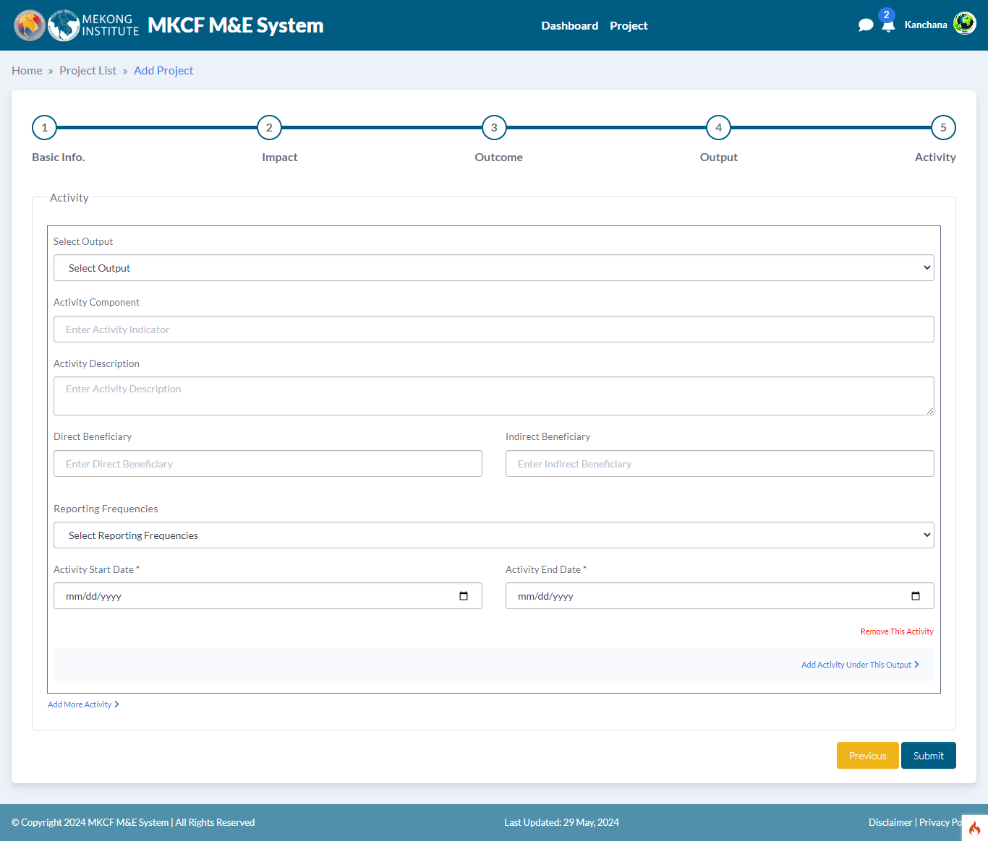

1. Report Financial Process

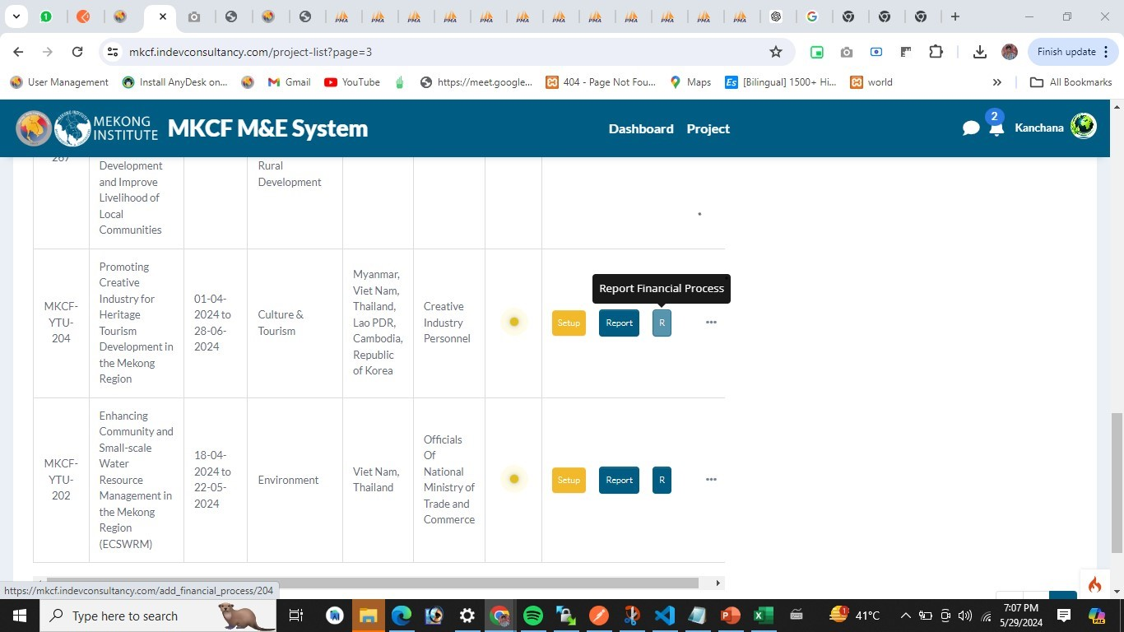

1. Report Financial Process Add From

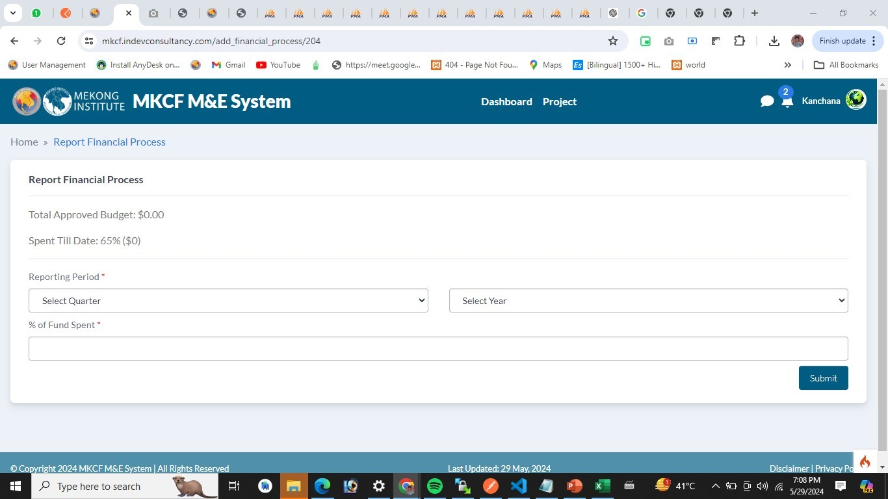

1. Project view Budget Information

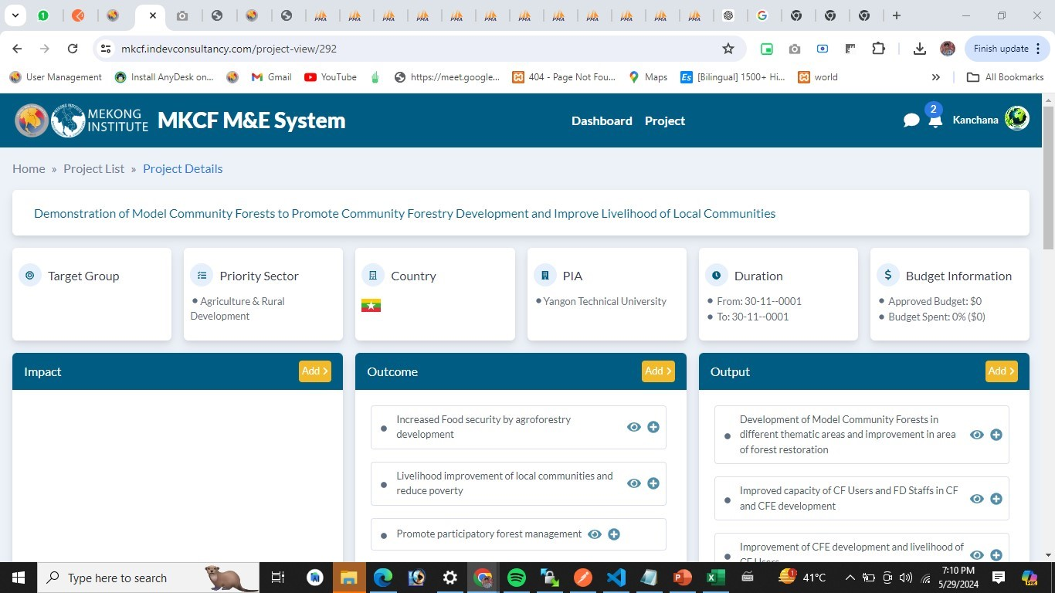

1. Project List add Graph

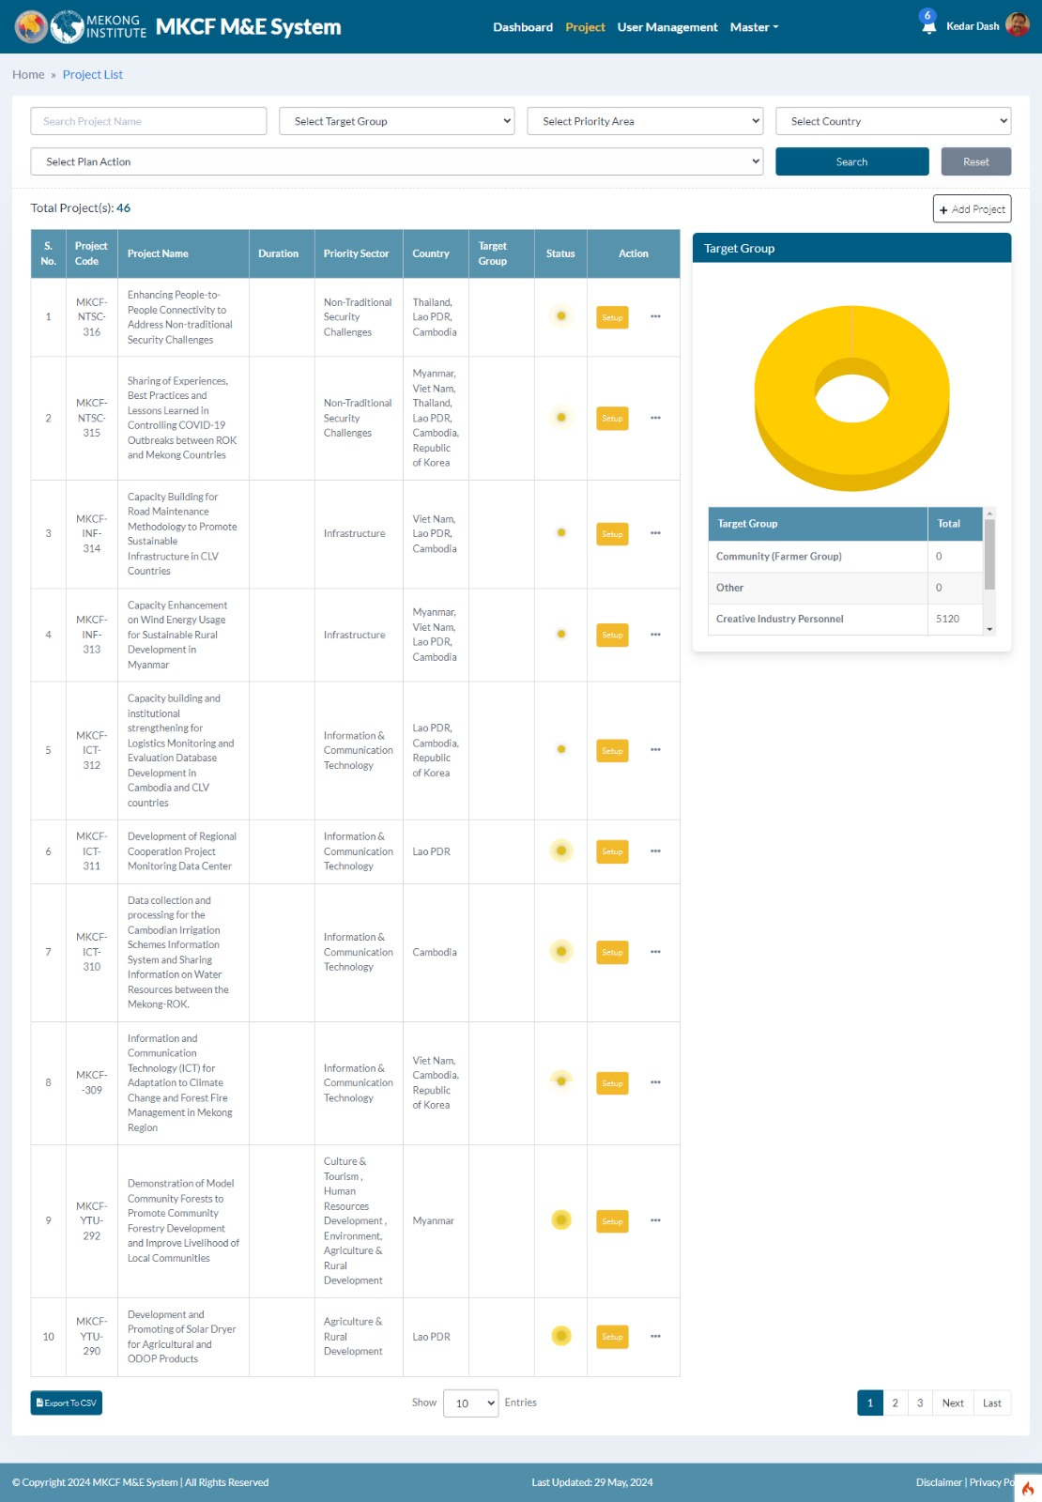

1. Project List add filter Plan Action 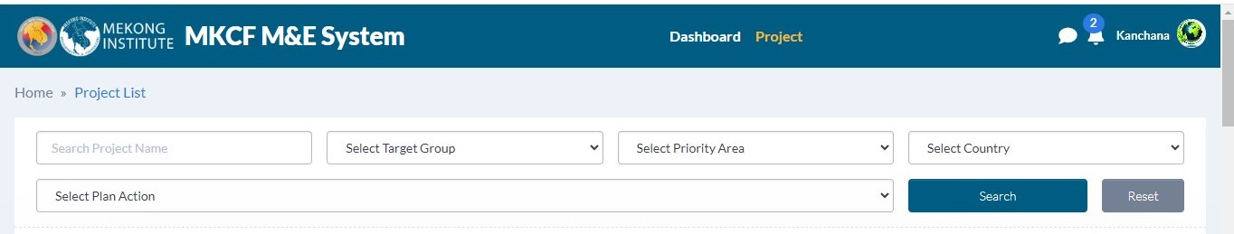
2. Report Activity Budget Remove

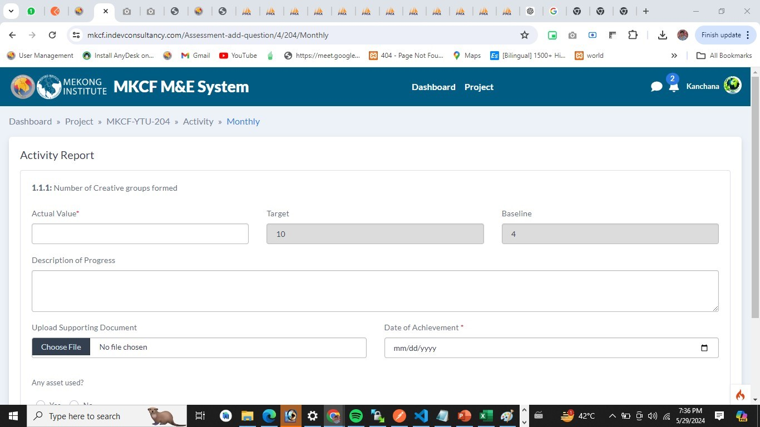

1. Document Category project add and edit project 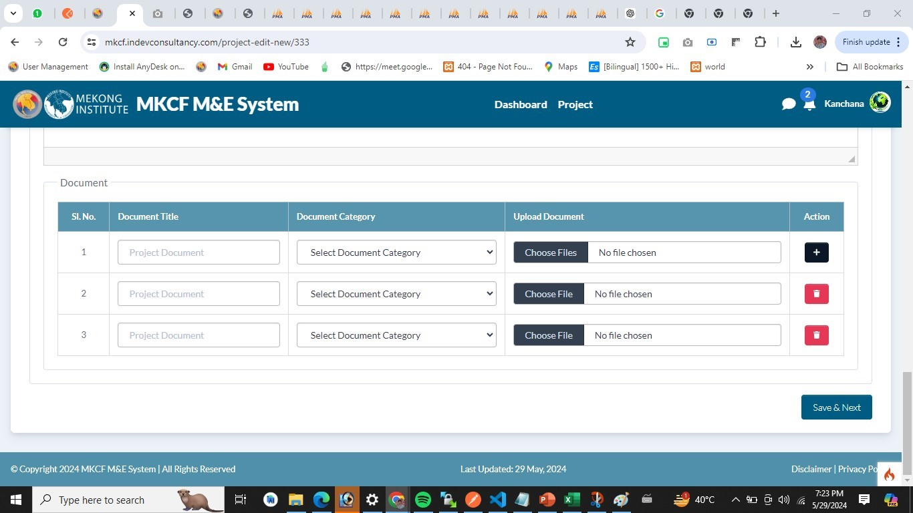
2. Project view Indirect Beneficiary and Direct Beneficiary 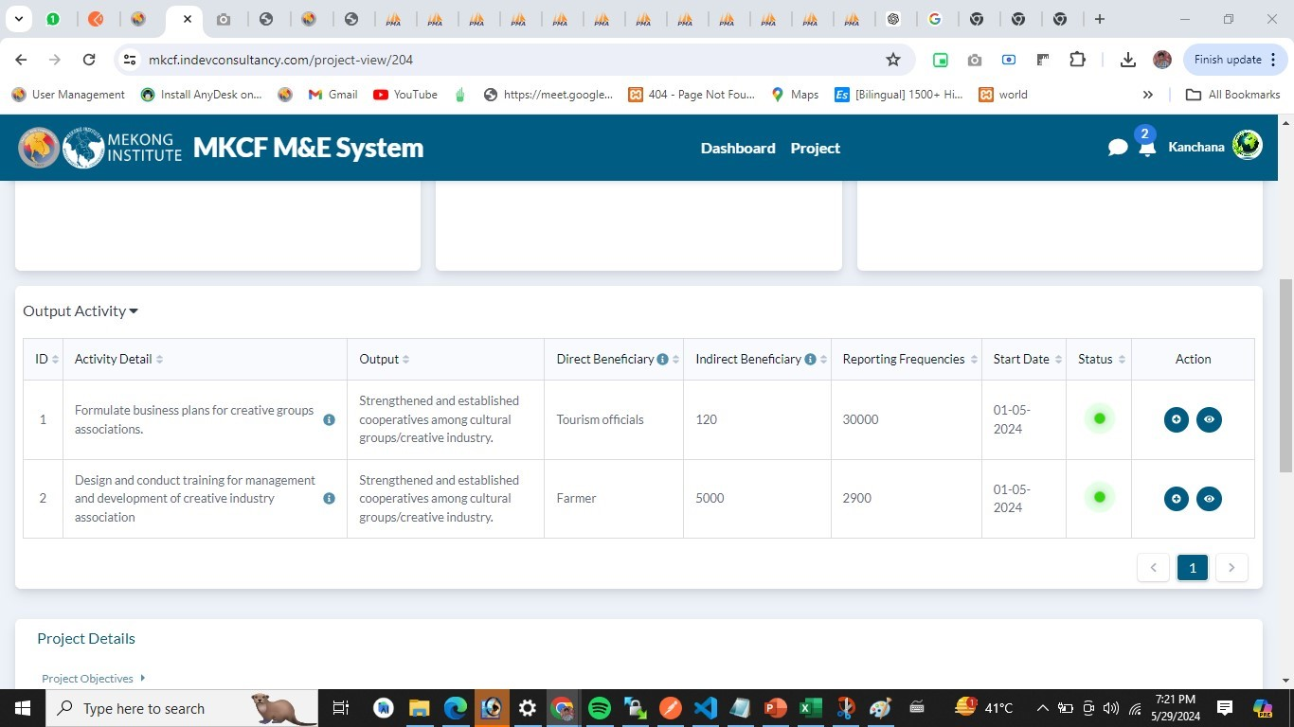
3. PIA add Select Document Category 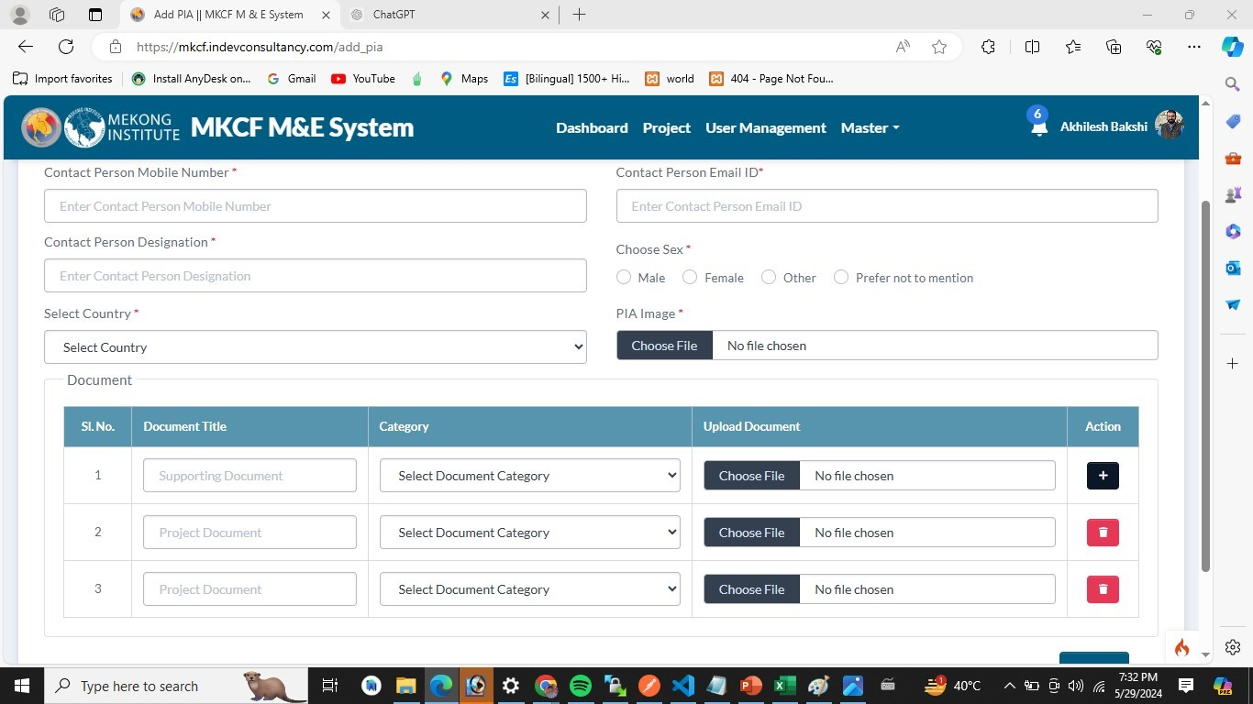
4. PIA Document Category view 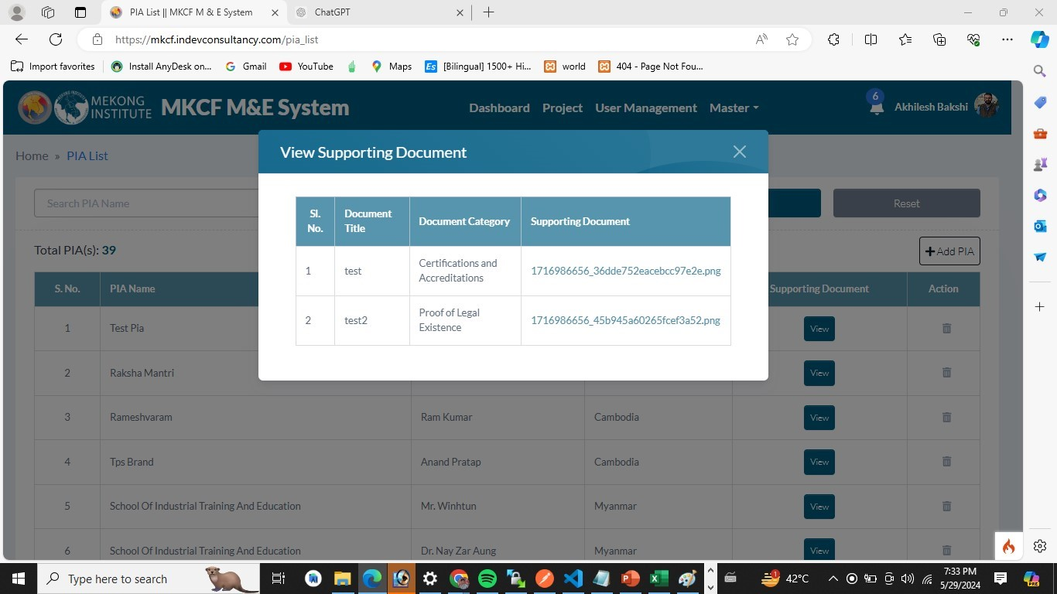
5. Project Approve Budget and Edit 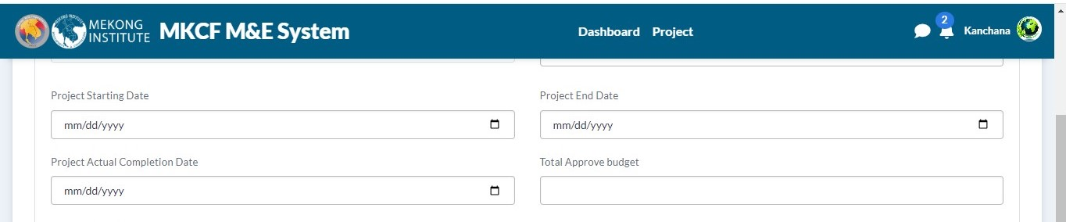ssss